EXPT NO:3 | CLEANSE DATA BY HANDLING MISSING VALUES, OUTLIERS, AND INCONSISTENCIES USING TABLEAU AND POWERBI
DATE: 10.07.2026

PRE-LAB QUESTIONS (PROVIDE BRIEF ANSWERS TO THE FOLLOWING QUESTIONS)
- What are the potential impacts of missing values in a dataset, and what are some common strategies to address them in Tableau and Power BI?

Missing values can reduce data accuracy and lead to incorrect analysis. They can be handled by replacing them with the mean, median, mode, or "Unknown", or by removing incomplete records using Data Interpreter (Tableau) or Power Query (Power BI).

- What is the importance of identifying and addressing outliers in a dataset? How can outliers affect data analysis and model performance?

Outliers can distort statistics, create misleading visualizations, and reduce model accuracy. They should be identified and handled by filtering, capping, or flagging them for further analysis.

- What types of data inconsistencies might you encounter during data cleansing, and how can Tableau and Power BI help in resolving them?

Common inconsistencies include duplicate values, inconsistent text (e.g., "South" and "South Region"), incorrect date formats, and missing values. Tableau uses Group/Alias, while Power BI uses Power Query Replace Values and formatting tools to standardize data.

- How do you identify patterns in data using visualizations to spot missing values, outliers, and inconsistencies?

Charts such as scatter plots, box plots, histograms, and bar charts help identify unusual values, missing data, and inconsistent patterns in the dataset.

- What is the role of calculated fields in data cleansing, and how can they be used to handle missing values and outliers in Tableau/Power BI?

Calculated fields create new values based on formulas. They can replace missing values using IFNULL() in Tableau or IF(ISBLANK()) in Power BI, and flag or adjust outliers for analysis.

IN-LAB EXERCISE:
OBJECTIVE:
To clean a given dataset (e.g., Superstore Sample in Tableau and Financials/Sales Data in Power BI) by identifying and resolving missing values, outliers, and inconsistencies using built-in tools, ensuring the dataset is accurate and ready for analysis.
PROCEDURE:
  - Open the Tool and Connect Dataset o Open Tableau Desktop , Power BI Desktop.
    - Load the built-in dataset (Sample - Superstore in Tableau / Financials in Power BI).
    - Preview the dataset to understand its structure.
  - Initial Inspection o Explore fields such as Sales, Profit, Region, or Product Category.
    - Check for nulls, inconsistent text values (e.g., "South Region" vs. "South"), or date formatting issues.
  - Handling Missing Values o Use Data Interpreter (Tableau) / Power Query (Power BI) to highlight nulls. o Replace missing numerical values with mean/median, and text with "Unknown".
    - Use calculated fields: IFNULL([Field], Default) in Tableau or IF(ISBLANK([Field]), "Unknown", [Field]) in Power BI.
  - Detecting and Managing Outliers o Create scatter or box plots for Sales and Profit to identify extreme values.
    - Choose strategies:
      - Filter them temporarily.
      - Apply caps using calculated columns.
      - Flag them with labels for review.
  - Resolving Inconsistencies o Use Group/Alias (Tableau) / Replace Values (Power BI) to standardize text.
    - Normalize data formats, such as date fields or currency units.
- Validation with Visuals
    - Build dashboards with histograms, bar charts, and box plots to visually confirm improvements.
    - Compare before/after cleaning stages for accuracy.
- Save the Cleaned Dataset o Save as .twbx (Tableau) / .pbix (Power BI).
o Optionally export cleaned data to .csv.
- Summary Dashboard
o Create a visual summary of the cleaning process, highlighting:
      - Fields corrected.
      - Nulls/outliers removed or adjusted.
      - Clean dataset metrics (record count, completeness %).

Experiment Dataset:
  - Tableau: Sample - Superstore
  - Power BI: Financials or Sales Data
How to Access:
Tableau:
  - Navigate to: Start Page → Sample Workbooks
  - Or: Help → Sample Data → Open Sample Data Folder
Screenshot:
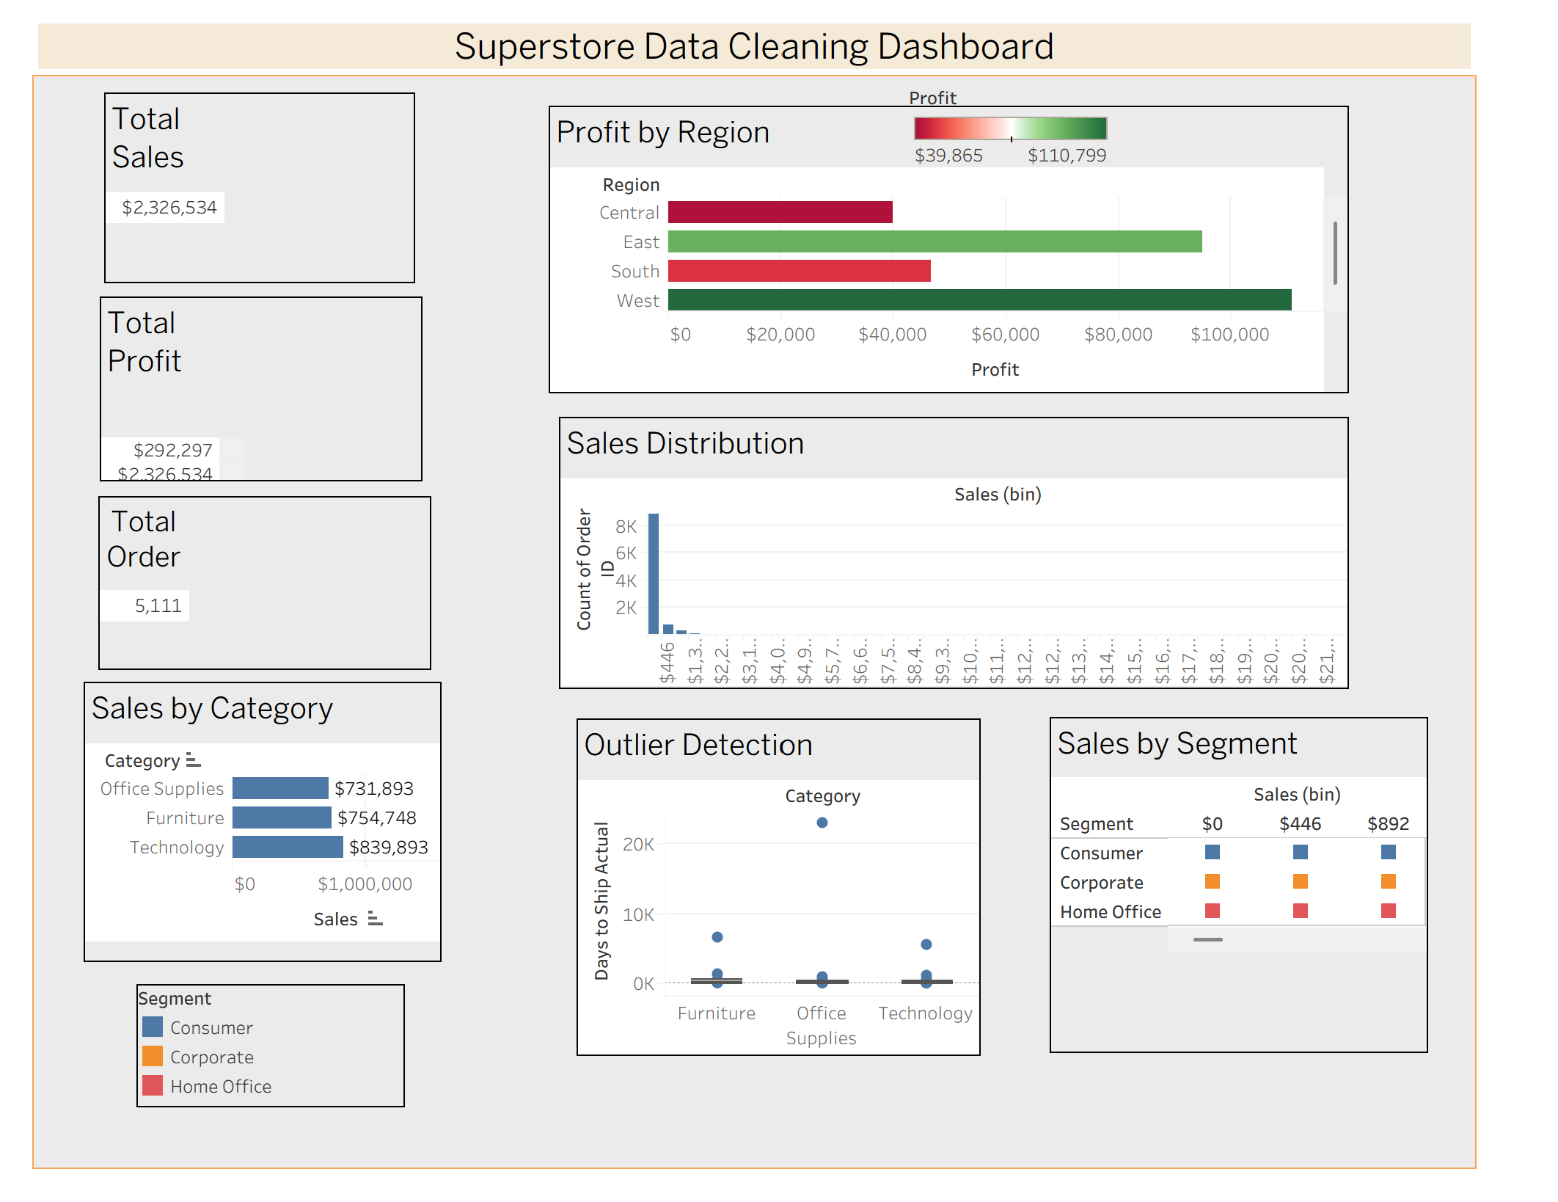
Power BI:
  - Navigate to: Home → Get Data → Excel → Choose sample datasets (e.g., Financial Sample.xlsx)
  - Microsoft also hosts Power BI sample datasets online.
Screenshot:
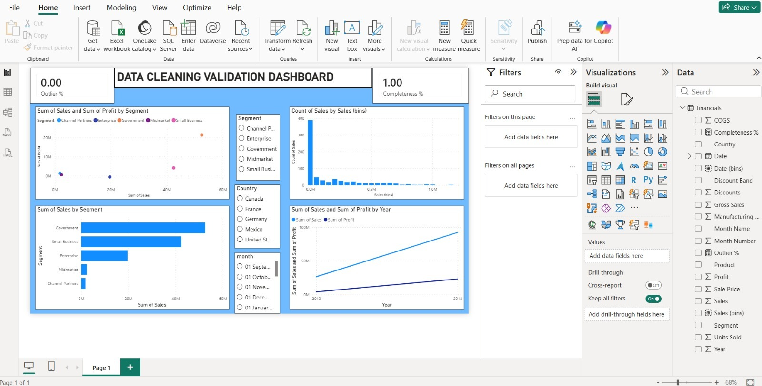
Fields Used:
  - Sales
  - Profit
  - Region
  - Category
  - Order Date / Transaction Date

POST-LAB QUESTIONS (PROVIDE BRIEF ANSWERS TO THE FOLLOWING QUESTIONS)
- What method did you use to replace missing values in numeric fields?
I replaced missing numeric values with the mean or median using calculated fields and Power Query/Data Interpreter tools

- How were outliers handled in your dataset and what visual confirmed their correction?

Outliers were filtered or capped using calculated fields. Box plots and scatter plots confirmed that extreme values were handled correctly.

- What inconsistencies were detected in categorical values and how were they standardized?

Different spellings and naming formats (such as "South" and "South Region") were standardized using Group/Alias in Tableau and Replace Values in Power BI.

- Describe how calculated fields helped in resolving data issues.

Calculated fields replaced missing values, identified blank records, calculated corrected values, and flagged outliers, improving data quality.

- How did your dashboard demonstrate the effectiveness of the data cleaning process?

The dashboard showed before-and-after comparisons, reduced missing values, corrected inconsistencies, improved data completeness, and cleaner visualizations for accurate analysis.

RESULT:

The dataset was successfully cleaned and prepared for accurate analysis using Tableau and Power BI. Issues such as nulls, inconsistencies, and outliers were identified and resolved, improving data quality significantly.

ASSESSMENT

Description |  | Max Marks | Marks Awarded
Pre Lab Exercise |  | 5
In Lab Exercise |  | 10
Post Lab Exercise |  | 5
Viva |  | 10
 | Total | 30
 |  | Faculty Signature

